Prairie mounds activities

Emma,

Apologies things have gotten off to a slow start. It looks like you are set to arrive right as I am travelling internationally. The following activities (and any other ideas Adam/ Jim have) would be decent places to start.

Keep an eye out for information about scheduling a PIV card pickup. You will need to first schedule an appointment to enroll, then once the enrollment activates you will need to schedule an appointment for card pickup. These appointments can be few and far between unfortunately. Once you have an appointment for card pickup we can get your computer configured with your login info and ship it out to you, in the meantime we will need to find a way for you to make do w/ whatever resources are at your disposal.

Please track your hours in ‘timesheet’ spreadsheets like the one attached. Every ~2 weeks (sort of up to you) you should submit one of these to me for my signature, then upload it to a contracting system (Quinn Miller can help give advice on this), at which point we process payments to you.

Below are some activities that could serve as a place to start, please log any activities in this space (or tasks Adam / Jim give you ) as hours worked.

Literature review
Read and summarize existing mechanisms for prairie mound formation, including some of the evidence presented by various authors. As you are doing this think about how the spatial distribution of Mima mounds (e.g., maps of their location and analyses of their geometry) and their relation to geology/soils might help discern between some of these mechanisms (or not). I’ve included a ‘literature’ folder with a pretty extensive suite of papers (apologies for not organizing it better), but a good place to start might be the GSA special volume (https://pubs.geoscienceworld.org/gsa/books/book/652/Mima-Mounds-The-Case-for-Polygenesis-and ), all of which is included.

Programming experience
Gain familiarity with programming in python and, in particular, raster/ image analysis through exercises on datacamp (SJ will buy you a subscription).

One useful exercise to help you gain some familiarity with raster processing in python might be to try and treat Mima mound identification as an edge detection problem (as there are lots of resources on edge detection online). A DEM can be viewed/processed much like any other picture, and one classic example of edge detection on an image you will see is of a set of coins (e.g., https://pyimagesearch.com/2021/05/12/opencv-edge-detection-cv2-canny/).
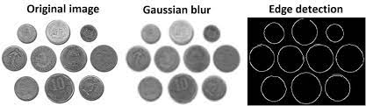
Figure 1. Edge detection on coins. Could we use one of these well travelled approaches on Mima mounds?

To approach this I would look to a workflow something like the following:

- Create 1 – 3 small (e.g., 10-100 of mb file size) cropped DEMs focused on Mima mound areas of varying complexity. When trying to implement something programmatically it helps to start with simple / small datasets. Something like the following 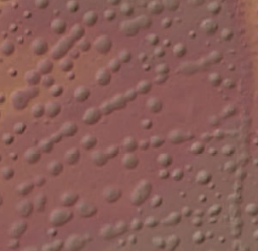
- A challenge with ‘edge detection’ here is that the edges of the mounds are actually somewhat subtle; they rise out of the intervening plane as opposed to being surrounded by an escarpment like the coins. The edge detection literature might help with this, but in this step you will need to think about how to enhance the boundaries of the edges to go from a the profile of a mima mound ‘bump’ (A) to an easy edge to detect like a coin resting on the ground (B).

- Can you then convert the edges to actual polygon features (or to some other geospatial datatype that you could export back to GIS)? I can also help w/ this when I get back.
Figure 2. A simple DEM with Mima mounds to use for experimenting.

Data organization – compile
- Digitize the existing index map of prairie mound extent (Figure 11 from the Introduction of the GSA Special Volume)
- Identify a few ‘type’ areas in Pacific North West where Mima mounds might exist across different geologic units / soil types
- Download relevant topographic data for ‘type’ area
- Survey type areas to gain a sense of what different type of mound patterns exist (literature review will help with this too);
  - Document the different characteristic morphologies of mounds; compile screenshots, descriptions of differences between morphologies. What might set these apart?

